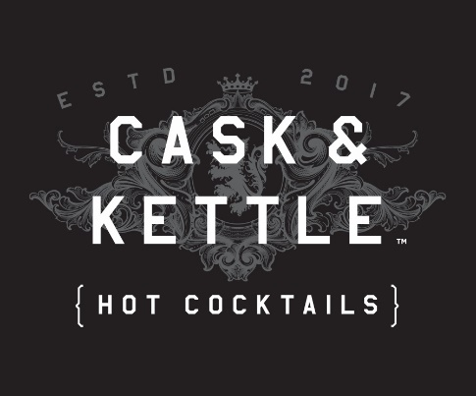
CONTACT

Lucinda Wright, Co-Founder & CEO
lucinda@caskandkettleusa.com
269-420-2529
Apres Beverages, LLC
62 Michigan Ave E
Battle Creek, MI 49017

FOR IMMEDIATE RELEASE
December 2, 2019

CASK & KETTLE Hot Cocktails Make You A Master Brewtender

Just in time for the holidays as a hostess gift or a signature drink at your next party, CASK & KETTLE is on shelves now in Michigan, Illinois, Missouri, Colorado, California, Oklahoma, Kansas, Washington State, Arizona and Nevada. Coming to Walmart stores this spring in Florida.

Battle Creek, Mich. — December 2, 2019 — Focused on true innovation in the spirits aisle, CASK & KETTLE is an easy way to prepare and serve a well-crafted hard coffee or cider cocktail. This new ready-to-brew line of boozy k-pods is currently available at a variety of large chains and independent retailers across 10 states. Go to https://caskandkettleusa.com/where-to-buy/ to find a store near you.

“The preliminary response from consumers, distributors and retailers alike has been outstanding,” said Lucinda Wright, co-founder and CEO of CASK & KETTLE. “We’re excited to see our drinks flood the market and help fire up idle Keurig-style coffee makers.”

Because of recent studies, we know that a fifth of drinkers prefer spirit-based drinks, and 41 percent of homes own single-serve coffee makers. CASK & KETTLE allows aspiring spirits aficionados the means to create their own curated beverages easily and at home.

The brainchild of former big brand executives struggling to get through a dull meeting, these cocktails appeal to the growing audience of spirits enthusiasts who want well-crafted drinks.

Pete Borozan, co-founder, adds, “We have spent a great deal of time perfecting the flavors and quality of CASK & KETTLE hot cocktails. Anyone who knows spirits and tries our drinks will not be disappointed.”

Rachel Brooks, proprietor of Moving Spirits in Manistee, Mich., was the first retailer to order. “CASK & KETTLE has been a great addition, and customer feedback has been nothing but positive. I’ve had to re-stock every week!” she explains.

Currently, CASK & KETTLE offers four drinks sold in five-count cartons:

- Irish Coffee (76 Proof)—Bold and whiskey-forward, this robust drink combines bold Irish Whiskey with notes of dark roasted coffee and buttery caramel flavors.

- Hot Blonde Coffee (74 Proof)—Aromatic and decadent with malty vanilla swirled in dark roasted coffee and crisp vodka.

- Mexican Coffee (60 Proof)—Smooth and sophisticated, this drink combines the light agave flavor of tequila with medium-roast coffee and a hint of Mexican chocolate.

- Spiked Cider (50 Proof)—Crisp and naturally sweet like the Michigan apples it contains, this cider has a fresh upfront tart apple flavor followed by a warm vodka and cinnamon finish.

Each k-pod contains liquid ingredients (no powders)—liquid distilled spirits, concentrated coffee and robust curated flavors. Just add your favorite coffee finishing touches, like creamer, coffee liqueurs, ice cream or add nothing at all.

ABOUT APRES BEVERAGES, LLC—Based in Battle Creek, Michigan, the founders of Apres Beverages, LLC., and the CASK & KETTLE brand seek to become the marketplace leader in ready-to-brew hot cocktails and champion the creation of new experiences that appeal to spirits drinkers.

ABOUT TEMPERANCE DISTILLING—Apres Beverages, LLC. has partnered with Temperance Distilling to help craft and blend CASK & KETTLE hot cocktails. Located in Temperance, Michigan, Temperance Distilling collaborates with unique spirits brands that represent a wide range of styles, tastes and formats.

Note to Editor: Photo and video assets are found at caskandkettleusa.com/press-kit

